 Permissions

Investigation Exercise

Answer the following questions using the Security Dictionary.

1. All of the system permissions which pertain to activities start with the letters "act". How many system permissions are there that pertain to activities?

2. Are the activity system permissions all static, all object-based, or are there some of each?

3. What is the name of the system permission a user must have to own an activity? How many roles is this permission currently assigned to?

4. How many permissions are associated to the Catastrophe Admin role?

5. There are five application permission keys which pertain to notes. Which one has the largest number of system permissions?

6. There are five application permission keys which pertain to notes. Which one is static?

7. VoidStopCheck is a page in the user interface. Are any permissions needed to view the page? To edit it?

Configuration Exercise

Configure ClaimCenter to meet the following customer requirement from Acme Insurance.

Requirement

In the base application, any adjuster can add, modify, or remove metropolitan (police) reports, which appear at the bottom of the loss details page. Acme Insurance wants to modify the application behavior so that only supervisors can remove existing reports. For the time being, they only want this restriction for the Auto LOB.

8. Create a new static system permission which will be used to control a user's ability to remove metropolitan reports. Add the system permission to the Claim Supervisor role.

9. Modify the user interface so that the Remove button at the top of the metro report list is visible only to users with the new permission.

Test Case

When you have completed your configuration, run the following test cases:

10. Log on to ClaimCenter as Andy Applegate, who is not a manager or supervisor. Navigate to any Auto claim. Put the Loss Details screen into Edit mode. Then, verify that he can add, but cannot remove metropolitan reports.

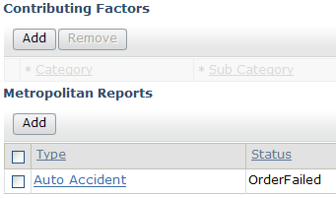

11. Log on to ClaimCenter as Sue Smith, who has the Claims Supervisor role. Navigate to the same claim. Put the Loss Details screen into Edit mode. Then, verify that she can remove metropolitan reports.

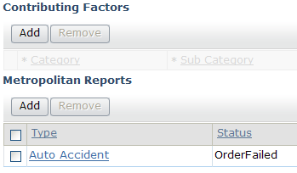
Challenge Configuration Exercise

This exercise is provided as additional practice for students who have completed the preceding tasks. The time allotted for this lesson does not take this exercise into account.

Configure ClaimCenter to meet the following customer requirement from Acme Insurance.

Requirement

ACME has determined that they want to further restrict access to the metro reports. In the base application, any adjuster can add, modify, or remove metropolitan (police) reports, which appear at the bottom of the loss details page. Acme Insurance wants to modify the application behavior so that only supervisors can add, modify, or remove them, but that anyone can view them. This restriction is for all LOB. The toolbar (which includes pagination controls) should not be removed in the process of limiting this access.

8. Create a new static system permission which will be used to control a user's ability to modify metropolitan reports. Add the system permission to the Claim Supervisor role.

9. Modify the user interface so that the Add and Remove buttons at the top of the metro report list are visible only to users with the new permission. Note: There are two possible ways of doing this. The first is to change the iterator buttons on each of the individual LOB DVs to have this permission. The better way to do this is to embed the existing metropolitan reports listview in a reusable container that is included by all of the individual DVs, and set the permission on the container. For this exercise, you should use the second option.

Test Case

When you have completed your configuration, run the following test cases:

10. Log on to ClaimCenter as Andy Applegate, who is not a manager or supervisor. Navigate to any claim. Put the Loss Details screen into Edit mode. Then, verify that he cannot add, modify, or remove metropolitan reports.

11. Log on to ClaimCenter as Sue Smith, who has the Claims Supervisor role. Navigate to the same claim. Put the Loss Details screen into Edit mode. Then, verify that she can add, modify, or remove metropolitan reports.

